angular 测试directive 细节

# karma配置

**preprocessors**: {  
 *//指定模板所在位置* **'templates/main/*.html'**: [**'ng-html2js'**] *//注意是ng-html2js 不是 html2js*},  
  
*// Custom ngHtml2JSPreprocessor options***ngHtml2JsPreprocessor**: {  
 *//测试中引用的模块名* **moduleName**: **'templateTestModule'**,  
 *//添加前缀  
 //在将html文件转换为js文件时，会将preprocessors中指定的路径添加到$templateCache  
 //而directive定义时，templateUrl会有./channel/前缀，  
 // 而perprocessors配置中并没有（见上几行的配置）* **prependPrefix**: **'./channel/'**,  
},

# html2js安装

npm install karma-html2js-preprocessor --save-dev -g

# nghtml2js安装

$ npm install karma-ng-html2js-preprocessor --save-dev –g

# 调试技巧：

I had kind of the same problem. Be sure you have the exact file match. Open the Google chrome console and check the file path is exactly the same.

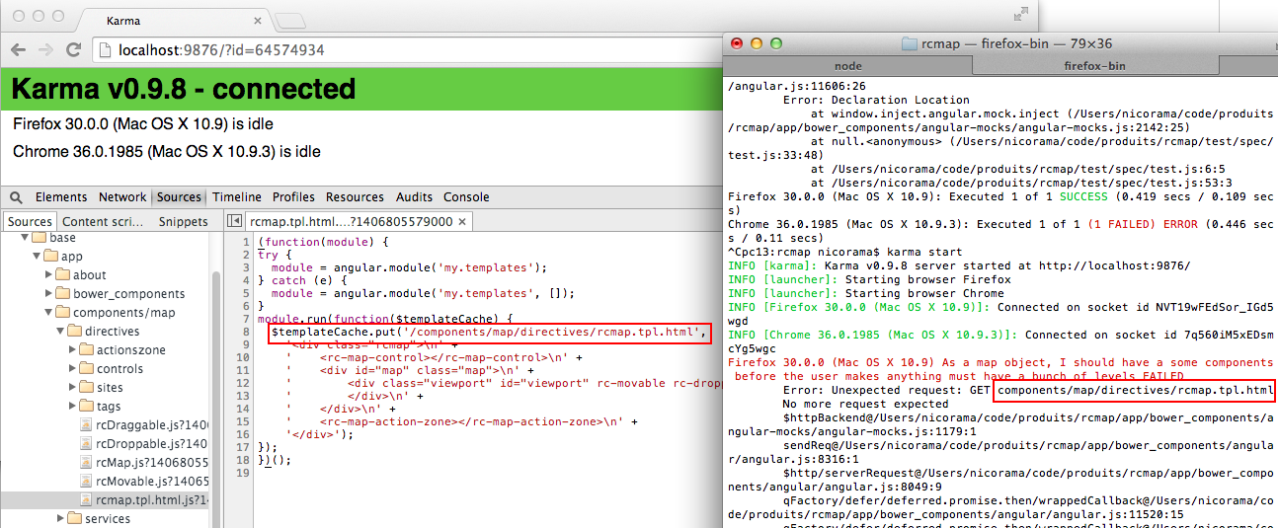

In the upper exemple, I had to add a "/" string in ngHtml2JsPreprocessor.stripPrefix and it worked. So I guess with Yeoman, you should use

ngHtml2JsPreprocessor: {

moduleName: 'templates',

stripPrefix: 'app/' //add a slash

}

# 多个template目录的配置方式

*// Custom ngHtml2JSPreprocessor options***ngHtml2JsPreprocessor**: {  
 *//测试中引用的模块名* **moduleName**: **'templateTestModule'**,  
 *//添加前缀  
 //在将html文件转换为js文件时，会将preprocessors中指定的路径添加到$templateCache  
 //而directive定义时，templateUrl会有./channel/前缀，  
 // 而perprocessors配置中并没有（见上几行的配置）* **prependPrefix**: **'./channel/'**,  
},

### 记得添加目录地址到files属性：

**files**: [  
 **'../js/angular.min.js'**,  
 **'../js/angular-ui-router.js'**,  
 **'../js/d3.min.js'**,  
 **'../js/angular-mocks.js'**,  
 **'*.js'**,  
 **'./js/ngmodules/*.js'**,  
 **'./js/ngmodules/service/*.js'**,  
 **'./js/ngmodules/directive/*.js'**,  
 **'./js/directives/*.js'**,  
 **'./js/configs/*.js'**,  
 **'./js/services/*.js'**,  
 **'./js/controllers/*.js'**,  
 **'./test/*.js'**,  
 **'./test/ngmodules/*.js'**,  
 **'./test/directives/*.js'**,  
 **'./test/configs/*.js'**,  
 **'./test/services/*.js'**,  
 **'./test/services/contour/*.js'**,  
 **'./test/controllers/*.js'**,  
 **'./templates/main/*.html'**,  
 **'./templates/roomdetail/*.html'**],

## ***[参考文献]***

https://stackoverflow.com/questions/23429126/error-unexpected-request-during-karma-angular-unit-test